

**Magibomb**

User Manual

**Magibomb**

McGill University

ECSE 321 – Winter 2014

Implementers:

David Liu

Yike Liu

Eddy Lu

Xuzhi Shu

YaHan Yang

Christopher Reny

April 13th, 2014

# **Table of Contents**

1. Getting Started…………………….………………….………………….………………..4
   1. About Magibomb.…………….………………….………………….…………….4
   2. Minimum System Requirements...…….………………….………………….……4
   3. Installation…………….………………….………………….…………………….4
   4. Menu Control Reference…..………………….………………….………………..4
   5. Menu …………...…….………………….………………….…………………….5
   6. Game Modes..……………………………………………………………………..6
   7. Game Characters and Special Abilities.….………………….…………………….7
   8. Stats………………………………………………………………………………..9
2. Game Play…………….…………….……….………………….………………….…….10
   1. Script tutorial…..………….……………………………………………………..10
   2. Game Control Reference..….…………….………………….…………………...11
   3. Game Screen……………….………………….………………….……………...12
   4. Obstacles and Power up……………….………………….……………………...14
   5. Enemies and Bosses.…….….………………….………………….……………..15
   6. Pause game......…………….………………….………………….………………17
   7. Music Setting..…….………………….………………….………………………18
   8. Levels and Statistics......………….………………….………………….………..18
   9. Two player mode...…………….………………….………………….………….19
   10. Quitting and Saving the game …………………………………………………...20
3. Defect of The Game………………..………………….………………….….………….20
   1. Known bugs..……….………………….………………….………………..……20

# **Getting Started**

## **About Magibomb**

A game composed of multiple stages with one or two player-controlled characters. The player’s goal for each stage is to kill all enemies and bosses. The player’s main method of attack involves placing bombs on the ground that explode after a set time. The player can also use special skills depending on the game character chosen. Enemies have a variety of attacks including the placement of collisions and projectiles.

## **Minimum System Requirements**

* Operation system: Windows XP/Vista/7/8, Mac
* Free Disk Space: 500MB
* Running Environment: Java SE Runtime Environment 8 or above.

## **Installation**

The game is developed with Java version 1.8.0 and up, so lower java versions will not be compatible. Please download Java SE Runtime Environment 8 or above.

**For Windows operating system:**

After downloading the game folder, double click Magibomb.jar or Magibomb.exe to start the game. Or you can use any java compiling software to run the game.

**For Mac:**

You can only click on Magibomb.jar.

Do not delete any item in the game folder; otherwise the game cannot function appropriately.

## **Menu Control Reference**

Using keyboard:

z – Conform

x – Go back

Arrow keys – shift

## **Menu**

Main menu:

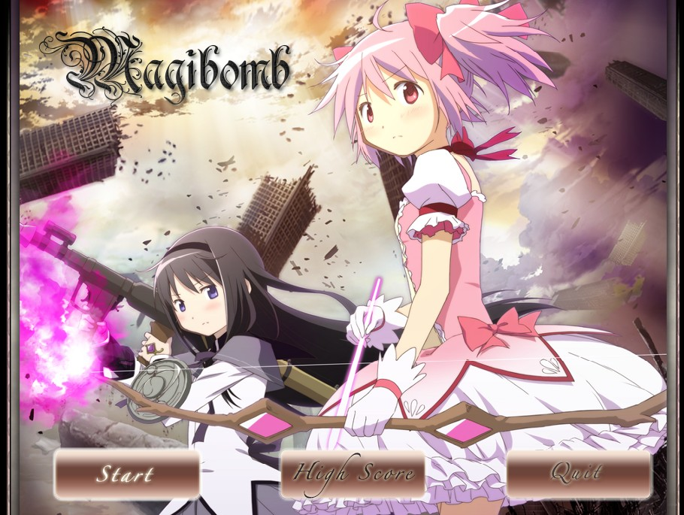

**Start:** Start a game

**High Score:** See your highest score for each stage

**Quit:** Quit the game

High Score menu:

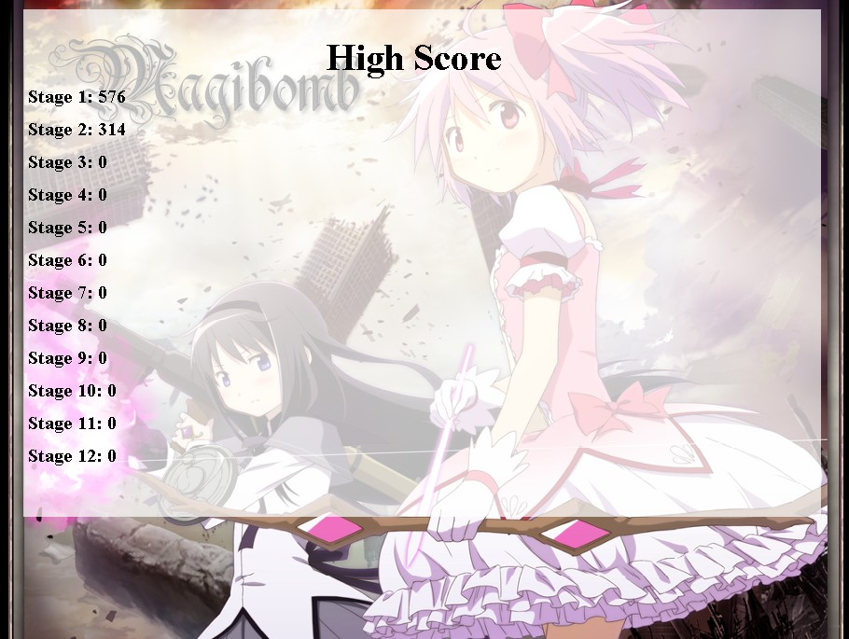

## **Game modes**

**Difficulty mode:**

Three levels of difficulty

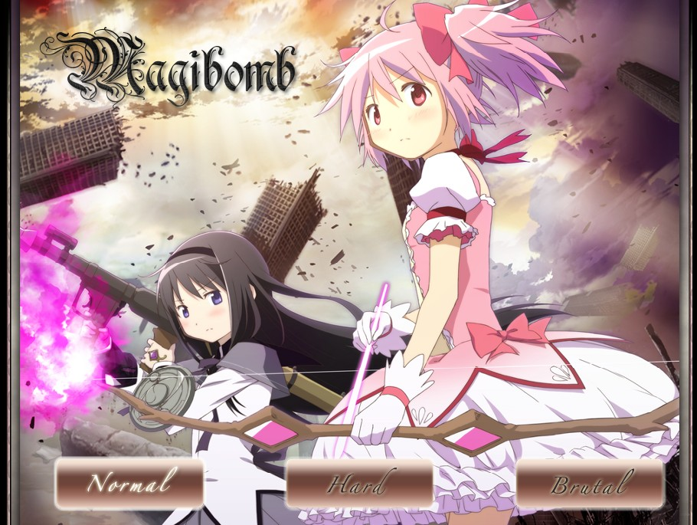

**One or Two Players mode:**

Either one player, or two players on the same computer

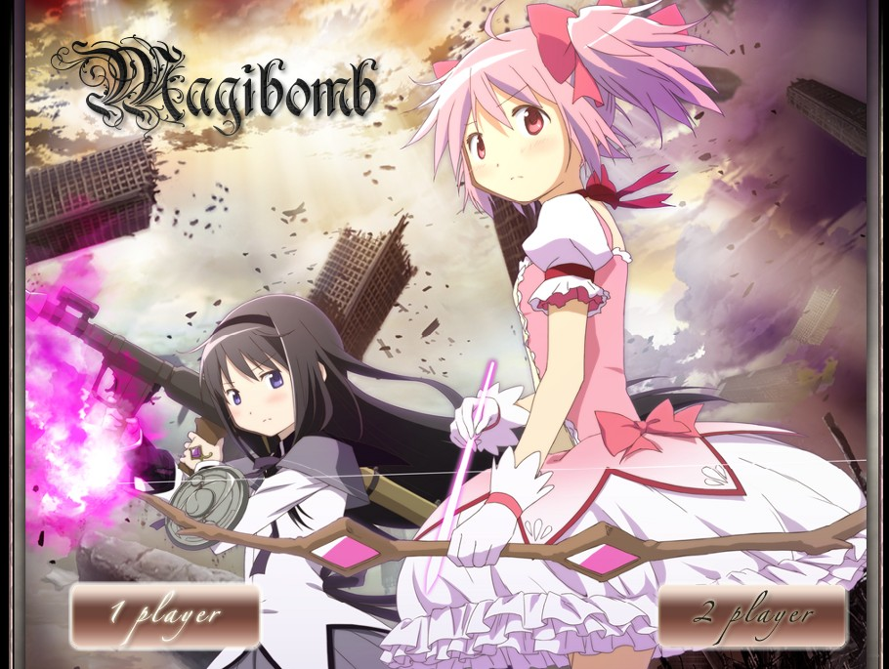

## **Game Characters and Special Abilities**

After setting the game modes, the players have to choose game characters. For One Player mode, the game would ask the player to choose one game character. For Two Players mode, the game would ask the players to choose two game characters. All the game characters have the same base stats, but each of them have their own special skill.

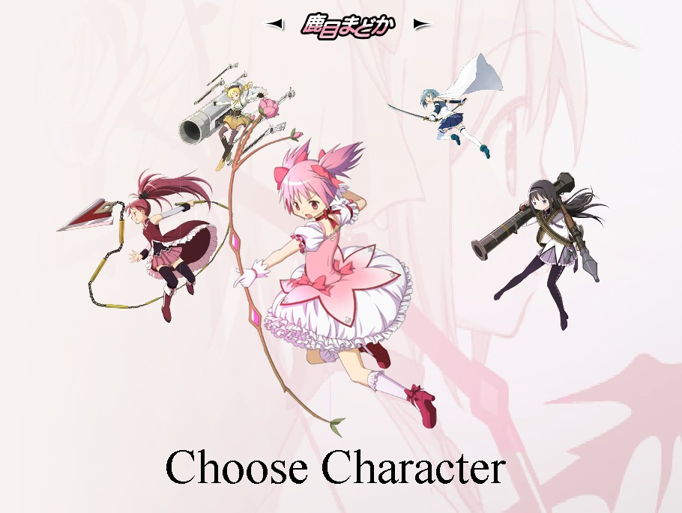



**Madoka**

**Special ability: Pink Arrow**

**Shoot a pink arrow that does damage equal to the player’s Damage stat divided by 2.**

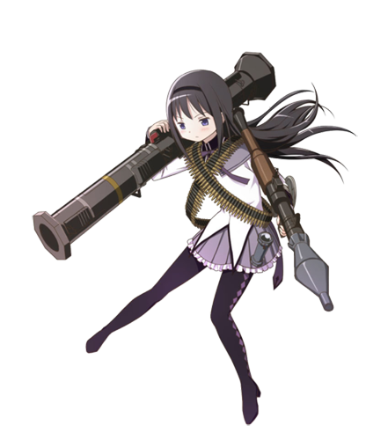

**Homura**

**Special Ability: Time Stop**

**Freeze everything for 5 seconds**



**Sayaka**

**Special Ability: Dash**

**Dash toward enemies making a damage equal to the player’s Damage stat divided by 3.**

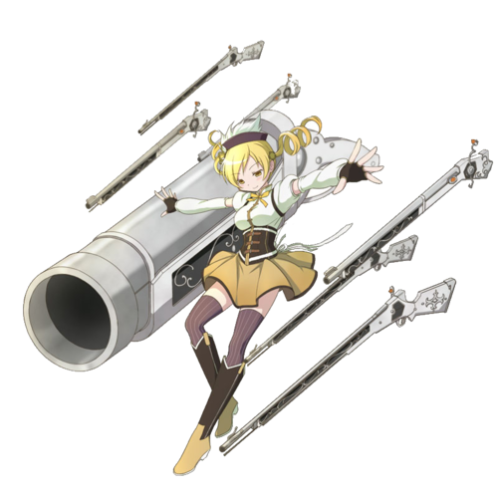**Mami**

**Special Ability: Tiro Finale**

**Hold the ability button to activate. Will**

**Continuously drain Mp until button released**

**or no more Mp left. Does damage**

**equalling to the player’s Damage stat**

**divided by 3 every tick**

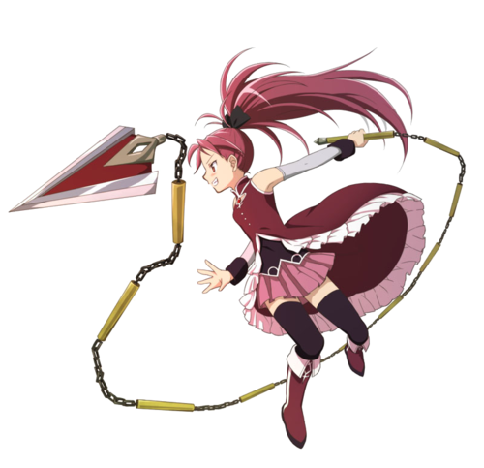

**Kyouko**

**Special Ability: Flame Guard**

**Protect herself by self-ignition. Collision with the enemies would damage the enemies by amount equal to the player’s damage stat divided by 2.**

## **Stats**

After choosing the game character, the player would see the stats of the character. The player would have points that he/she could add to some of these stats to improve the ability of the character. The number of points increases after each lever.

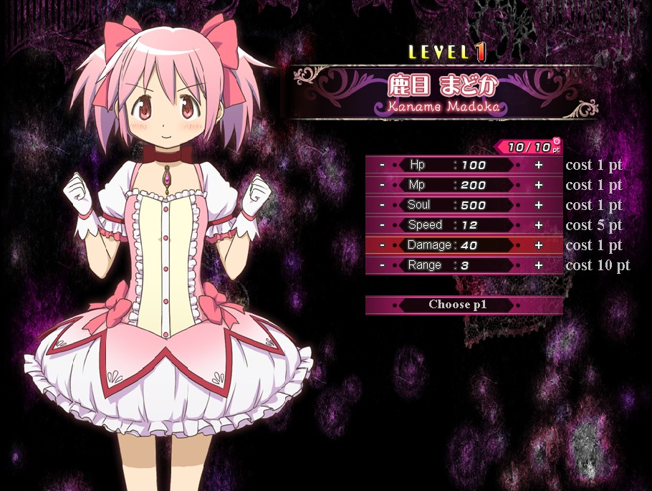

**Hp(Hit point):** Game over when reaches 0.

**Mp(Magic point):** Used for all kinds of actions(except movements), including placing bombs, kicking bombs and activating special abilities.

**Soul:** 30 soul currently

heals 4.5% Hp. Hp could not be grown back if soul reaches 0.

**Speed:** Moving speed

**Damage:** Bomb damage

**Range:** Number of grids the bomb's fire can cover.

# **Game Play**

#### **Script tutorial**

Before the game start, there would have tutorials for special stages. Press “z” to continue the tutorial.

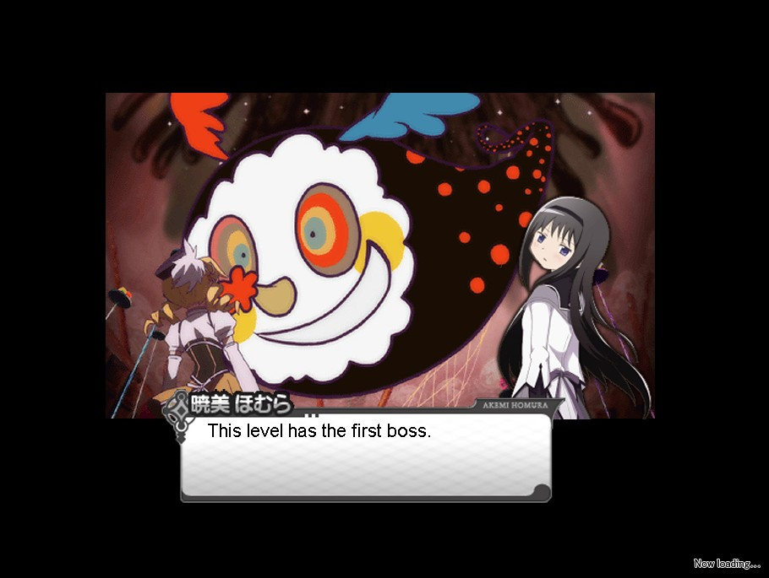

#### **Game Control Reference**

p– Pause game

**One Player Mode:**

z – Place bomb

x – Kick bomb

c – Use special ability

Space – refill Mp with Soul

Arrow keys – Movement

**Two Player Mode:**

Player 1:

Comma – Place Bomb

Period – Kick Bomb

Question Mark – Special Ability

Right control – Refill Mp with Soul

Arrow Keys – Movement

Player 2:

z – Place bomb

x – Kick bomb

c – Use special ability

Space – refill Mp with Soul

w- Shift up

s – Shift down

a – Shift left

d – Shift right

#### **Game Screen**

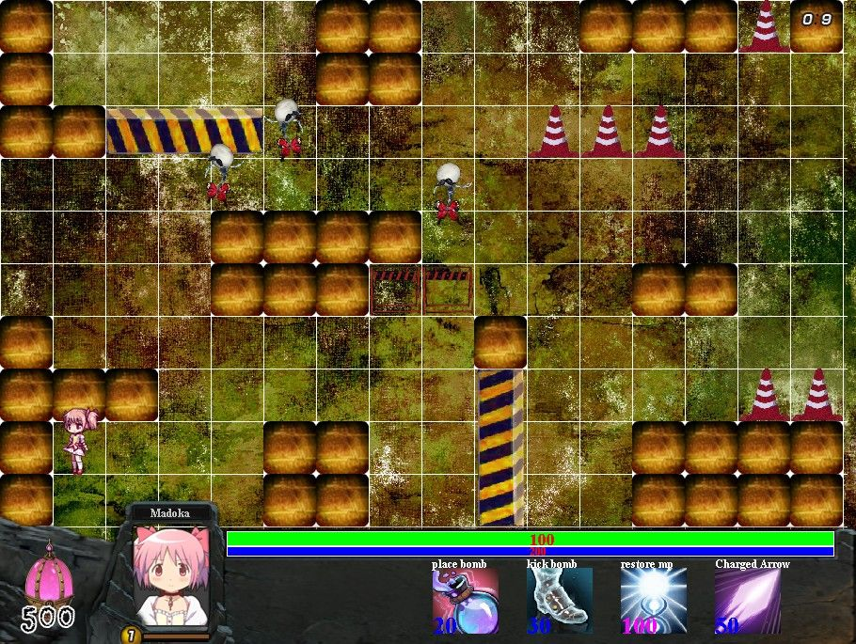

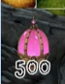 Soul value

 Character face, changes with respect to Hp.

Macintosh HD:Users:YaHan:Desktop:Screen Shot 2014-04-10 at 6.51.45 AM.png

Green : Hp value

Blue: Mp value

Macintosh HD:Users:YaHan:Desktop:Screen Shot 2014-04-10 at 6.51.54 AM.png Placing a bomb requires 20 Mp.

Macintosh HD:Users:YaHan:Desktop:Screen Shot 2014-04-10 at 6.52.00 AM.png Kicking a bomb requires 30 Mp.

Macintosh HD:Users:YaHan:Desktop:Screen Shot 2014-04-10 at 6.52.06 AM.png Refill Mp with soul equalling to max Mp divided by 2

**Macintosh HD:Users:YaHan:Desktop:Screen Shot 2014-04-10 at 6.52.11 AM.png** Character’s special skill and the Mp cost.

**Macintosh HD:Users:YaHan:Desktop:Screen Shot 2014-04-10 at 6.19.06 PM.png** Time in seconds.

#### **Obstacles and Power ups**

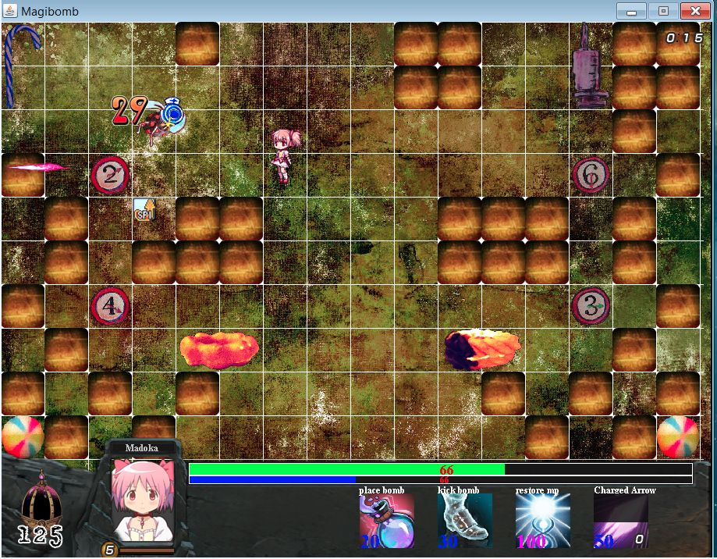

Normal obstacles could be blown up by bombs and an power-up item could appear after the obstacles disappear. Grab the an item by going to the grid and the item can either increase character’s moving speed or Hp value. Special obstacles stay still.

Macintosh HD:Users:YaHan:Desktop:Screen Shot 2014-04-10 at 7.06.32 AM.png Increases moving speed

Macintosh HD:Users:YaHan:Desktop:Screen Shot 2014-04-10 at 6.16.51 PM.png Increases attacking damage to enemies and bosses

Macintosh HD:Users:YaHan:Desktop:Screen Shot 2014-04-10 at 7.06.37 AM.png Increases Hp vale

#### **Enemies and Bosses**

**There are eight kinds of enemies** and one or more kinds of them can appear on the same stage. All of them have different Hp, movement speed, collision damage and experience provided when killed. All enemies will usually chase the player, but also move randomly at times:

throws scissors

transforms to spike kicks bomb

summons minions

charges at player kicks bomb



Shoot black beam

charges at player

**Five kinds of bosses:**



-Summons minions -summons minions

-spawns random spikes -shoots electric bolts

-throws scissors



- could charge at player VERY fast

-4 times the size as regular units

-ignores collision

-boss 2 phase 1

-spawns minions and changes to

phase 2 when killed



-shoots fire balls

-spawns random spikes on the map

-throws huge buildings

#### **Pause Game**

Press “P” to pause the game

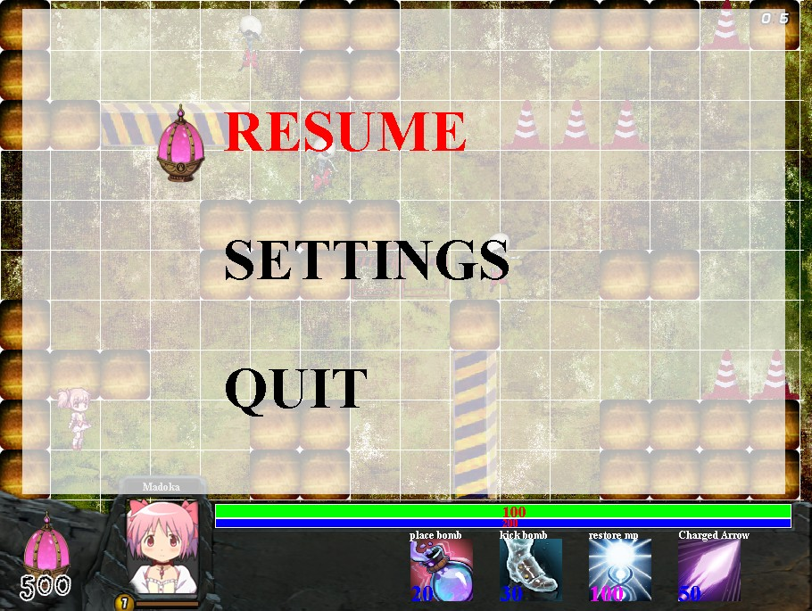

**Resume:** Resume the game

**Settings:** Music settings

**Quit:** Quit the game

#### **Music Setting**

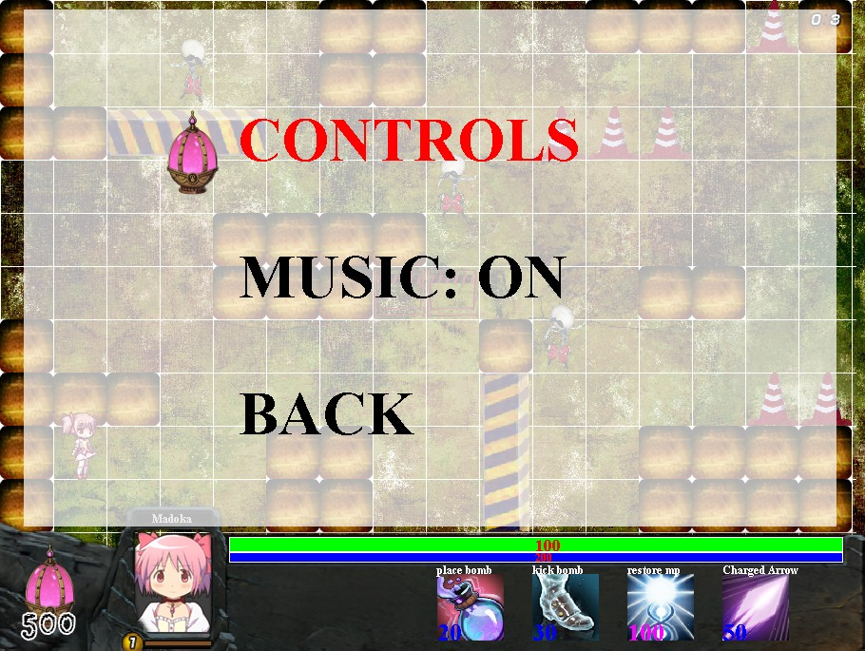Turn on or off the music by pausing the game, click “settings”, then “music:”.

#### **Level and Statistics**

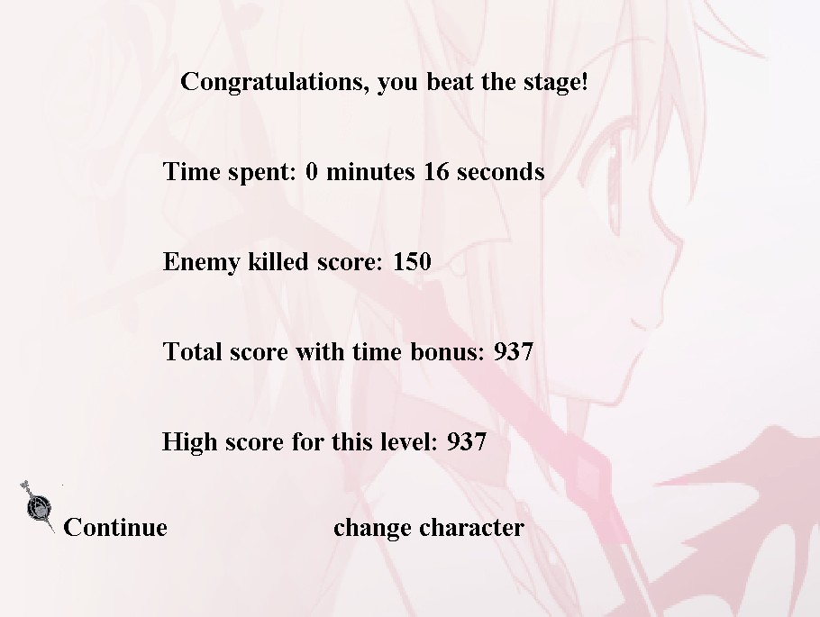After passing a level, you can either choose to continue to next level or change your game character.

**Enemy killed score:**

Number of killed enemy* kill score (depending on game difficulty)

**Total score with time bonus:**

Enemy killed score*100/times

**High score for this level:**

The highest score that the player got for this level

#### **Two Players Mode**

For two players mode, the screen shows the status of player 1 on the left and player 2 on the right. If one of the game characters dies, the other one is still able to play. For Two Player Mode control reference, see page 11.

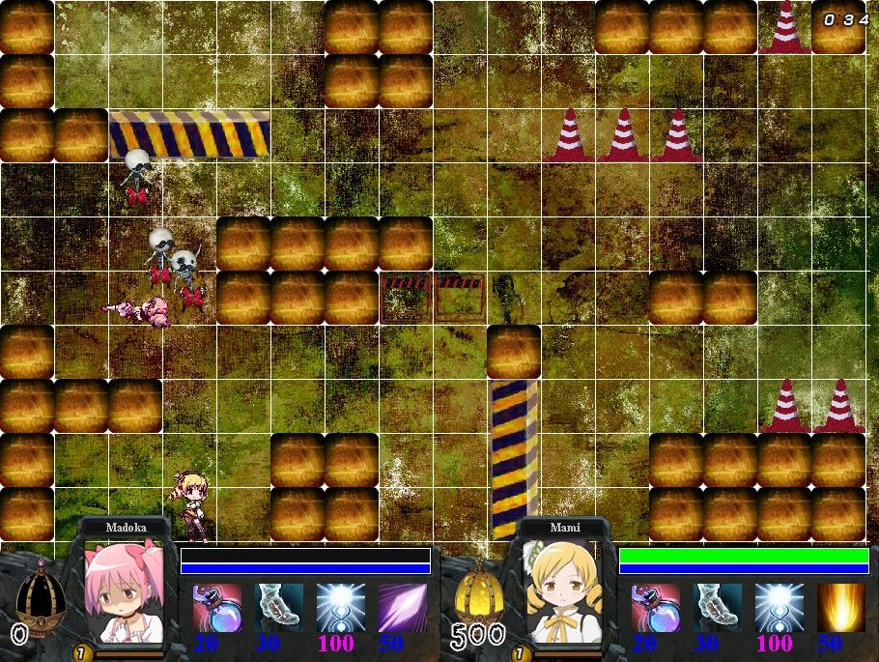

### **Quitting and Saving the Game**

The player can either quit the game from the main menu, or by pause the game or choose “quit”. The data of the player would be automatically saved in the game system and the player would be able to continue the game next time.

# **Defect of the Game**

### **Known bugs**

There are no any serious bugs that hinder game play. However, the game could be slow depending on the running environment. The player must install Java SE Runtime Environment 8 or above, otherwise there could have running problem.

Some minor bugs to be noted is that animations sometimes glitch for a second but will return to normal.